2026 AUGUST MEDITATION

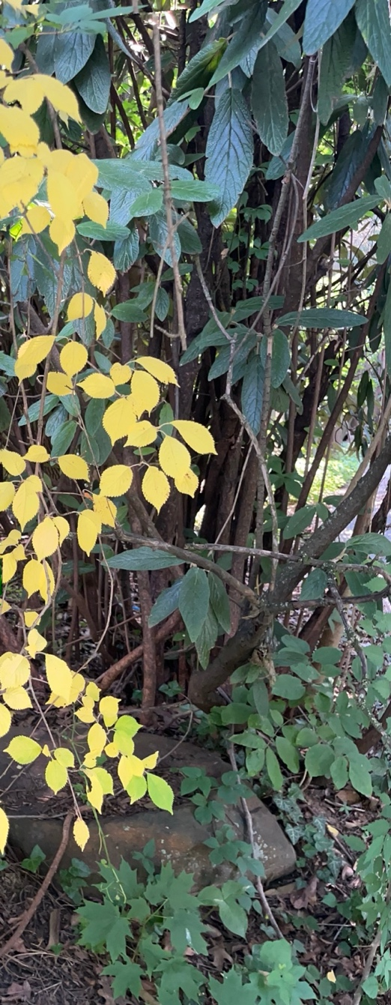
Beloved before Busy
As I walked by, a branch of yellow leaves among the green caught my eye. I stopped. In that brief pause, I realized how easily I move from one task to another without pausing to notice. We often measure our days by what we accomplish, yet Jesus continually invites us to remain in relationship with Him.
Jesus says, "Remain in me as I remain in you … Whoever remains in me bears much fruit" (John 15:4–5). Our mission is sustained not by our own efforts, but by remaining in His love.
August, with its holidays, retreats, and change of rhythm, invites us not simply to rest, but to allow Christ to renew us for the work entrusted to us.
As Cornelia Connelly reminds us, "Be then like the Holy Child Jesus in your Thoughts, in your Words, and in your Actions."
The more deeply we remain in Christ, the more fully we become present to one another. Before we are called to do, we are called to belong. We are beloved before we are busy.

Reflection Questions
- What is inviting me to pause and be with Christ today?
- How is Christ shaping my thoughts, my words, and my actions to reflect His love?
- What in my everyday surroundings is Christ inviting me to notice today?

