Website Meditation July 2026 -- pause 3 seconds wherever there’s a double space
The sections in red below are a continuous thought, so let your voice suggest that

Can you remember an early experience of being awestruck?

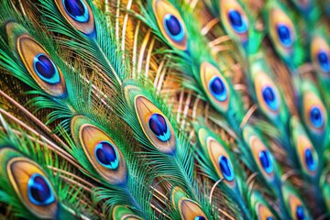
Mine was when I first saw a peacock displaying its stunning tail feathers.

If I were a tetrachromat (one of the estimated 12% of females with four cone cells in their eyes instead of three),

I would have been 'wowed' by millions more colours.

This enhanced perception would be comparable to the heightened senses of some creatures.

Tetrachromacy can serve as a powerful metaphor for seeing beyond, wider and deeper.

Without exception, mystics of all religions and none affirm that at the heart of the world is wonder and joy.

Cornelia can be counted among them, knowing “jubilee of heart not bargained for in this life of accepted suffering”.

Her heart’s legacy invites us to be open to astonishing gospel possibilities.

Perhaps community (in its widest sense) is our 'fourth cone cell', because we need each other's God-gifted vision to highlight opportunities that we miss completely if self-absorbed.

How stunningly awesome it is when we are invited into the joy of beauty and truth!

In what ways has someone else’s vision inspired you?

What joy for you came wrapped in “accepted suffering”?

May the eyes of our heart ever-seek wonder, mystery, joy - the very living presence of God in every person, place, and experience of our life.

