The Season of Creation then begins on September 1 to October 4, the Feast of St Francis of Assisi. 2.2 billion Christians are united for this worldwide celebration of prayer and action to protect our common home. You, too, can join them! As followers of Christ from around the globe, we share a common responsibility as caretakers of God’s creation. Our human wellbeing is interwoven with the wellbeing of our planet. This year, the theme for the season is “Jubilee for the Earth”.

SEASON OF CREATION SEPTEMBER 1.
St Francis of Assisi reminds us that our common home is like a sister with whom we share our life, and a beautiful mother who opens her arms to embrace us…..This sister now cries out to us because of the harm we have inflicted on her by our irresponsible use and abuse of the goods with which God has endowed her….The violence present in our hearts, wounded by sin, is also reflected in the symptoms of sickness evident in the soil, in the water, in the air and in all forms of life. This is why the earth herself, burdened and laid waste, is among the most abandoned and maltreated of our poor….We have forgotten that we ourselves are dust of the earth; our very bodies are made up of her elements, we breathe her air and we receive life and refreshment from her waters. Pope Francis Laudato Si 1 and 2
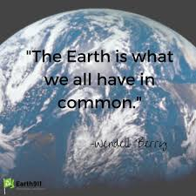

SEASON OF CREATION SEPTEMBER 2
St Francis is the example par excellence of care for the vulnerable and of an integral ecology lived out joyfully and authentically. He is the patron saint of all who study and work in the area of ecology and he is also much loved by non-Christians. He was particularly concerned for God’s creation and for the poor and outcast. He loved and was deeply loved for his joy, his generous self- giving, his openheartedness. He was a mystic and a pilgrim who lived in simplicity and in wonderful harmony with God, with others, with nature and with himself. He shows us just how inseparable the bond is between concern for nature, justice for the poor, commitment to society and interior peace. Pope Francis Laudato Si 10
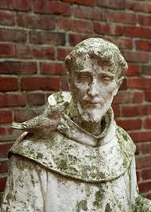

SEASON OF CREATION SEPTEMBER 3
The urgent challenge to protect our common home includes a concern to bring the whole human family together to seek a sustainable and integral development, for we know that things can change. The Creator does not abandon us ; he never forsakes his loving plan or repents of having created us. Humanity still has the ability to work together in building our common home. Pope Francis Laudato Si 13
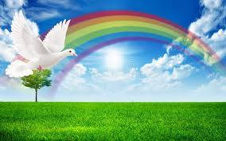

SEASON OF CREATION SEPTEMBER 4
Access to safe drinkable water is a basic and universal human right, since it is essential to human survival, and, as such, is a condition for the exercise of other human rights. Our world has a grave social debt towards the poor who lack access to drinking water because they are denied the right to a life consistent with their inalienable dignity…..Acute water shortages may occur within a few decades unless urgent action is taken. The environmental repercussions could affect billions of people; it is also conceivable that the control of water by large multinational businesses may become a major source of conflict in this century. Pope Francis Laudato Si 30
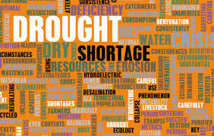
SEASON OF CREATION SEPTEMBER 5
The earth’s resources are being plundered because of short-[sighted approaches to the economy, commerce and production…….Each year sees the disappearance of thousands of plant and animals species which we will never know, which our children will never see, because they have been lost forever. The great majority become extinct for reasons related to human activity. Because of us thousands of species will no longer give glory to God by their very existence, nor convey their message to us. We have no such right. Pope Francis Laudato Si 33
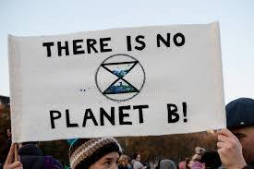
SEASON OF CREATION SEPTEMBER 6
The deterioration of the environment and of society affects the most vulnerable people on the planet…..yet they are the majority of the planet’s population, billions of people… they frequently remain at the bottom of the pile. This is due partly to the fact that many professionals, opinion makers, communications media and centres of power, being located in affluent urban areas, are far removed from the poor with little direct contact with their problems….Today we have to realise that a true ecological approach always becomes a social approach…so as to hear both the cry of earth and the cry of the poor. Pope Francis Laudato Si 49
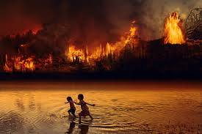
SEASON OF CREATION SEPTEMBER 7
The creation accounts in the book of Genesis contain, in their own symbolic and narrative language, profound teachings about human existence and its historical reality. They suggest that human life is grounded in three fundamental and closely intertwined relationships: with God, with our neighbour and with earth itself. According to the Bible, these three vital relationships have been broken both outwardly and within us. This rupture is sin. ….today sin is manifest in all its destructive power in wars, the various forms of violence and abuse, the abandonment of the most vulnerable and attacks on nature. Pope Francis Laudato Si 66
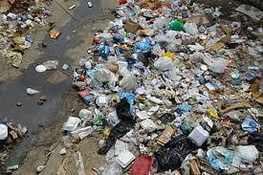
SEASON OF CREATION SEPTEMBER 8
A sense of deep communion with the rest of nature cannot be real if our hearts lack tenderness, compassion and concern for our fellow human beings. ….Everything is connected. Concern for the environment thus needs to be joined to a sincere love for our fellow human beings and an unwavering commitment to resolving the problems of society…Everything is related and we human beings are united as brothers and sisters on a wonderful pilgrimage, woven together by the love God has for each of his creatures and which also unites us in fond affection with brother sun, sister moon, brother river and mother earth. Pope Francis Laudato Si 91
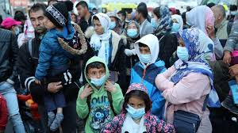
SEASON OF CREATION SEPTEMBER 9
In talking to his disciples Jesus would invite them to recognise the paternal relationship God has with all his creatures. With moving tenderness he would remind them that each one of them is important in God’s eyes. …The Lord was able to invite others to be attentive to the beauty that there is in the world because he himself was in constant touch with nature, lending it an attention full of fondness and wonder. As he made his way throughout the land, he often stopped to contemplate the beauty sown by his Father and invited his disciples to perceive a divine message in things: “Lift up your eyes and see how the fields are already white for harvest…”
Pope Francis Laudato Si 97
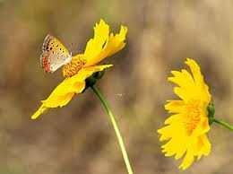

SEASON OF CREATION SEPTEMBER 10

A certain way of understanding human life and activity has gone awry….Humanity has entered a new era in which our technical prowess has brought us to a crossroads….our immense technological development has not been accompanied by a development in human responsibility, values and conscience….Human beings and material objects no longer extend a friendly hand to one another; the relationship has become confrontational. This has made it easy to accept the idea of unlimited growth which proves so attractive to economists, financiers and experts in technology. It is based on the lie that there is an infinite supply of earth’s goods and this leads to the planet being squeezed dry beyond limit. Pope Francis Laudato Si 106
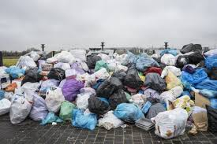

SEASON OF CREATION SEPTEMBER 11

When we fail to acknowledge as part of reality the worth of a poor person, a human embryo, a person with disabilities – to offer just a few examples – it becomes difficult to hear the cry of nature itself; everything is connected. Once the human being declares independence from reality and behaves with absolute dominion, the very foundations of our life begin to crumble…There can be no renewal of our relationship with nature without a renewal of humanity itself.
Pope Francis Laudato Si 117

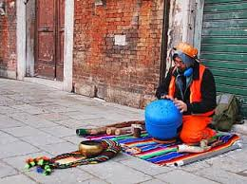
SEASON OF CREATION SEPTEMBER 12

We should not be surprised to find… the rise of a relativism which sees everything as irrelevant unless it serves one’s own immediate interests…. Relativism is the same disorder which drives one person to take advantage of another, to treat others as mere objects, imposing forced labour on them or enslaving them to pay their debts. The same kind of thinking leads to the sexual exploitation of children and abandonment of the elderly who no longer serve our interests….justifies buying the organs of the poor for resale or use in experimentation, or eliminating children because they are not what their parents wanted. This same “use and throw away” logic generates so much waste because of the disordered desire to consume more than what is really necessary. Pope Francis Laudato Si 123

SEASON OF CREATION SEPTEMBER 13

When we speak of the “environment” what we really mean is a relationship existing between nature and the society which lives in it. Nature cannot be regarded as something separate from ourselves or as a mere setting in which we live. We are part of nature…We are not faced with two separate crises, one environmental and the other social, but rather one complex crisis which is both social and environmental. Strategies for a solution demand an integral approach to combating poverty, restoring dignity to the excluded and at the same time protecting nature. Pope Francis Laudato Si 139
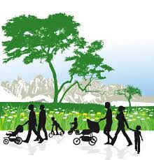
SEASON OF CREATION SEPTEMBER 14

It is essential to show special care for indigenous communities and their cultural traditions. …For them, land is not a commodity but a gift from God and from their ancestors who rest there, a sacred space with which they need to interact if they are to maintain their identity and values. When they remain on their land they themselves care for it best. Nevertheless in various part so the world, pressure is being put upon them to abandon their homelands to make room for agricultural or mining projects which are undertaken without regard for the degradation of nature and culture. Pope Francis Laudato Si 146
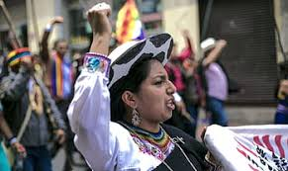

SEASON OF CREATION SEPTEMBER 15

Lack of housing is a grave problem in many parts of the world, both in rural areas and in large cities…Not only the poor, but many other members of society as well, find it difficult to own a home. Having a home has much to do with a sense of personal dignity and the growth of families. This is a major issue for human ecology.

SEASON OF CREATION SEPTEMBER 16

Society as a whole and the state in particular, are obliged to defend and promote the common good….In the present condition of global society, where injustices abound and growing numbers of people are deprived of basic human rights and considered expendable, the principle of the common good immediately becomes a summons to solidarity and a preferential option for the poorest of our brothers and sisters….This option is in fact an ethical imperative essential for attaining the common good. Pope Francis Laudato Si 158

SEASON OF CREATION SEPTEMBER 17

The common good also extends to future generations….Once we start to think about the kind of world we are leaving to future generations we look at things differently; we realise that the world is a gift which we have freely received and must share with others. …What kind of world do we want to leave to those who come after us, to children who are growing up now? When we ask ourselves what kind of world we want to leave behind we think in the first place of its general direction, its meaning and its values. Unless we struggle with these deeper issues I do not believe that our concern for ecology will produce significant results. Pope Francis Laudato Si 160

SEASON OF CREATION SEPTEMBER 18

What is the purpose of our life in this world? Why are we here? What is the goal of our work and all our efforts? What need does the earth have of us?….Leaving an inhabitable planet to future generations is first and foremost up to us…for it has to do with the ultimate meaning of our earthly sojourn. We may well be leaving to coming generations debris, desolation and filth. The pace of consumption, waste and environmental change has so stretched the planet’s capacity that our contemporary lifestyle, unsustainable as it is, can only precipitate catastrophes such as those which even now periodically occur in different areas of the world. Pope Francis Laudato Si 161
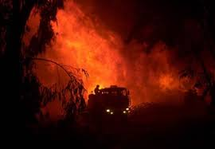

SEASON OF CREATION SEPTEMBER 19

Beginning in the last century…there has been a growing conviction that our planet is a homeland and that humanity is one people living in a common home. …A global consensus is essential for confronting the deeper problems which cannot be resolved by unilateral actions on the part of individual countries. Such a consensus could lead, for example to planning a sustainable and diversified agriculture, developing renewable and less polluting forms of energy, encouraging a more efficient use of energy, promoting a better management of marine and forest resources, and ensuring universal access to drinking water. Pope Francis Laudato Si 164

SEASON OF CREATION SEPTEMBER 20

Worldwide the ecological movement has made significant advances thanks to the efforts of many organizations of civil society…environmental questions have increasingly found a place on public agendas…This notwithstanding, recent World Summits on the environment have not lived up to expectations because, due to lack of political will, they were unable to reach truly meaningful and effective global agreements on the environment…International negotiations cannot make significant progress due to positions taken by countries which place their national interests above the global common good. Pope Francis Laudato Si 166

SEASON OF CREATION SEPTEMBER 21

The twenty-first century, whilst maintaining systems of governance inherited from the past, is witnessing a weakening of the power of nation states, chiefly because the economic and financial sectors, being transnational, tends to prevail over the political. ..To manage the global economy; to revive economies hit by the crisis; …to bring about integral and timely disarmament, food security and peace; to guarantee the protection of the environment and to regulate migration there is an urgent need of a true world political authority. Pope Francis Laudato Si 175
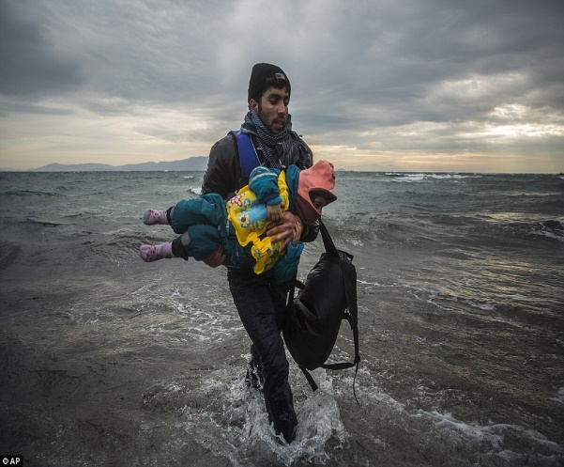

SEASON OF CREATION SEPTEMBER 22

Is it realistic to hope that those who are obsessed with maximising profits will stop to reflect on the environmental damage which they will leave behind for future generations? Where profits alone count, there can be no thinking about the rhythms of nature, its phases of decay and regeneration, or the complexity of ecosystems which may be gravely upset by human intervention. Moreover, biodiversity is considered at most a deposit of economic resources available for exploitation, with no serious thought for the real value of things, their significance for persons and cultures, or the concerns and needs of the poor. Pope Francis Laudato Si 190
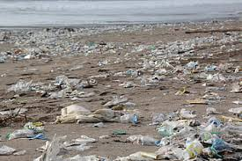

SEASON OF CREATION SEPTEMBER 23

The majority of people living on our planet profess to be believers. This should spur religions to dialogue among themselves for the sake of protecting nature, defending the poor and building networks of respect and fraternity. Pope Francis Laudato Si 201

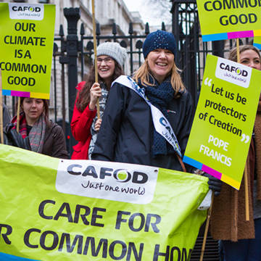

SEASON OF CREATION SEPTEMBER 24

Many things have to change course, but it is we human beings above all who need to change. We lack an awareness of our common origin, of our mutual belonging and of a future to be shared with everyone…. Since the market tends to promote extreme consumerism…people can easily get caught in a whirlwind of needless buying and spending…When people become self-centred and self-enclosed their greed increases. The emptier a person’s heart is, the more he or she needs things to buy, own and consume. ..a genuine sense of the common good also disappears…Obsession with a consumerist lifestyle, above all when few people are capable of maintaining it, can only lead to violence and mutual destruction. Pope Francis Laudato Si 204

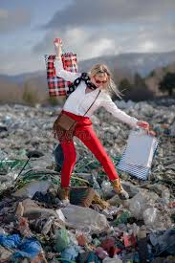

SEASON OF CREATION SEPTEMBER 25

All is not lost. Human beings, while capable of the worst, are also capable of rising above themselves, choosing again what is good, and making a new start, despite their mental and social conditioning. We are able to take an honest look at ourselves, to acknowledge our deep dissatisfaction and to embark on new paths to authentic freedom. No system can completely suppress our openness to what is good, true and beautiful, or our God-given ability to respond to his grace at work deep in our hearts. I appeal to everyone throughout the world not to forget this dignity which is ours. Pope Francis Laudato Si 205

SEASON OF CREATION SEPTEMBER 26

It is wonderful how education can bring about real changes in lifestyle. Education in environmental responsibility can encourage ways of acting which directly and significantly affect the world around us, such as avoiding the use of plastic and paper, reducing water consumption, separating refuse, cooking only what can reasonably be consumed, showing care for other living beings, using public transport or car-pooling, planting trees, turning off unnecessary lights, or any number of other practices. Pope Francis Laudato Si 211

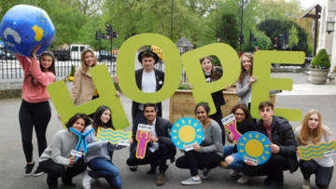
SEASON OF CREATION SEPTEMBER 27

I would like to offer Christians a few suggestions for an ecological spirituality grounded in the convictions of our faith….such a spirituality can motivate us to a more passionate concern for the protection of the world….this conversion calls for…gratitude, a recognition that the world is God’s loving gift….a loving awareness that we are not disconnected from the rest of creatures, but joined in a splendid universal communion… Pope Francis Laudato Si 220

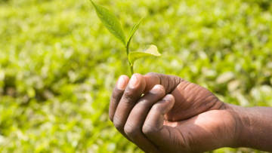

SEASON OF CREATION SEPTEMBER 28

Those who enjoy more and live better each moment are those who have given up dipping here and there, always on the look -out for what they do not have. They experience what it means to appreciate each person and each thing, learning familiarity with the simplest things and how to enjoy them. So they are able to shed their unsatisfied needs, reducing their obsessiveness and weariness. Even living on little they can live a lot, above all when they cultivate other pleasures and find satisfaction in fraternal encounters, in service, in developing their gifts, in music and art, in contact with nature and in prayer. Pope Francis Laudato Si 223
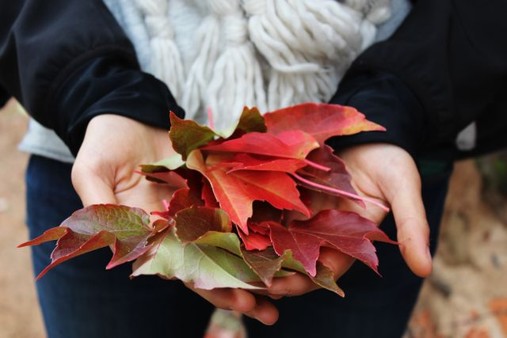

SEASON OF CREATION SEPTEMBER 29

No one can cultivate a sober and satisfying life without being at peace with him or herself….Inner peace is closely related to care for ecology and for the common good because, lived out authentically, it is reflected in a balanced lifestyle together with a capacity for wonder which takes us to a deeper understanding of life. Nature is filled with words of love, but how can we listen to them amid constant noise, interminable and nerve-wracking distractions, or the cult of appearances. Pope Francis Laudato Si 225

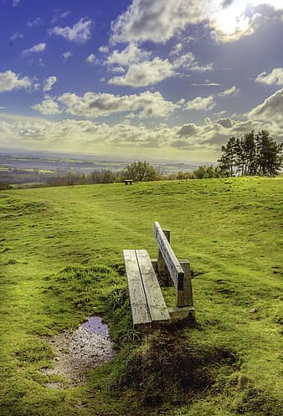

SEASON OF CREATION SEPTEMBER 30

We are speaking of an attitude of heart, one which approaches life with serene attentiveness, which is capable of being fully present to someone…which accepts each moment as a gift from God to be lived to the full. Jesus taught us this attitude when he invited us to contemplate the lilies of the field and the birds of the air….He was completely present to everyone and to everything and in this way he showed us the way to overcome that unhealthy anxiety which makes us superficial, aggressive and compulsive consumers. Pope Francis Laudato Si 226

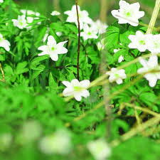

SEASON OF CREATION OCTOBER 1

One expression of this attitude (of heart) is when we stop and give thanks to God before and after meals. I ask all believers to return to this beautiful and meaningful custom. That moment of blessing, however brief, reminds us of our dependence on God for life; it strengthens our feeling of gratitude for the gifts of creation; it acknowledges those who by their labours provide us with these goods; and it affirms our solidarity with those in greatest need. Pope Francis Laudato Si 227
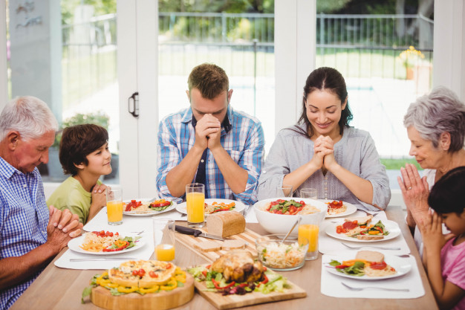

SEASON OF CREATION OCTOBER 2

It is in the Eucharist that all that has been created finds its greatest exaltation….Joined to the Incarnate Son, present in the Eucharist, the whole cosmos gives thanks to God. Indeed the Eucharist is itself an act of cosmic love….The world which came forth from God’s hands returns to him in blessed and undivided adoration….The Eucharist is also a source of light and motivation for our concerns for the environment, directing us to be stewards of all creation. Pope Francis Laudato Si 236
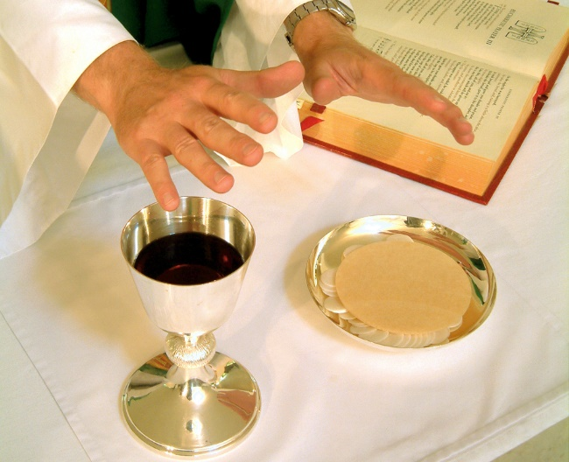

SEASON OF CREATION OCTOBER 3
We come together to take charge of this home which has been entrusted to us…Let us sing as we go. May our struggles and our concern for this planet never take away the joy of our hope. God, who calls us to generous commitment and to give him our all, offers us the light and strength needed to continue on our way. In the heart of this world the Lord of Life, who loves us so much, is always present. He does not abandon us, he does not leave us alone, for he has united himself definitively to our earth, and his love constantly impels us to find new ways forward. Praise be to him! Pope Francis Laudato Si 245

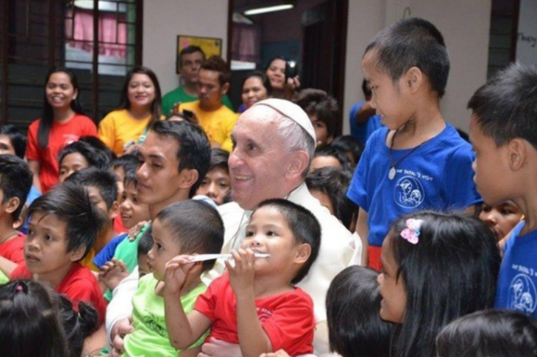

SEASON OF CREATION OCTOBER 4: FEAST OF ST FRANCIS OF ASSISI
We read in the Gospel that Jesus says of the birds of the air that “not one of them is forgotten before God.” How then can we possibly mistreat them or cause them harm? I ask all Christians to recognise and to live fully this dimension of their conversion. May the power and light of the graced we have received also be evident in our relationship to other creatures and to the world around us. In this way we will help nurture that sublime fraternity with all creation which St Francis of Assisi so radiantly embodied. Pope Francis Laudato Si 221

