User's Guide for Virtual Tour of Mayfield Chapel

This tour is best viewed on a desktop computer or large-screen laptop.

Click “Start Tour” Button to enter tour.

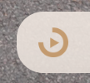
You will start outside the chapel. The screen will automatically be turning 360 degrees. If you want the automatic turning to stop, push this button located in the bar in the bottom right corner of the screen:

The tour is comprised of six, 360 degree-photographed scenes, which are meant to be viewed 360 degrees around, from ceiling to floor. You can use your mouse to grab anywhere on the page and drag it to look around. You can also click on these icons in the bottom right hand of the screen to zoom and move around:
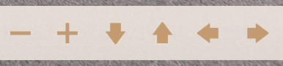

The six scenes can be found in the bottom left corner of the screen. You can click on each to be taken there.
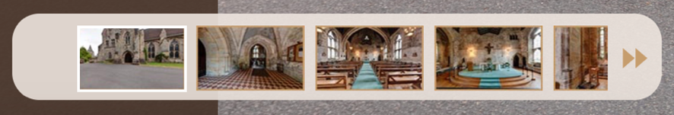

You can also click on the arrows to bring you to different scenes.
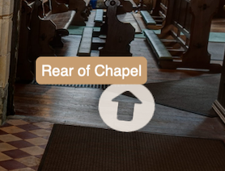
Click on these icons for photos and information:
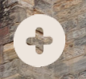

There is a vertical bar on the left side of the screen where you will find audio offerings “Welcome” and “Music”. You can click on each word to both start and stop the audio.

