ECO-ACTION FOR SEPTEMBER 17TH: DELVING DEEPER

Trees and forests: We cannot survive without trees and forests.

Delving Deeper:

During this Season of Creation, we are encouraged to pay attention to our planet home. Visit a forest or simply spend time with a near-by tree. Both are on sacred land. Notice the size, color, and texture of the bark, branches, and leaves. Imagine the thriving life within it and in the ground below your feet. Deepen your awareness of how it communicates with nearby trees, of how it preserves soil, of how it contributes to life.

List your feelings after your intimate exchange with a tree or forest area:

Send your words to Kathleen Dullea (kdullea@shcj.org) by Sept. 27. Words will be designed and displayed, as shown in this example (from a different topic):

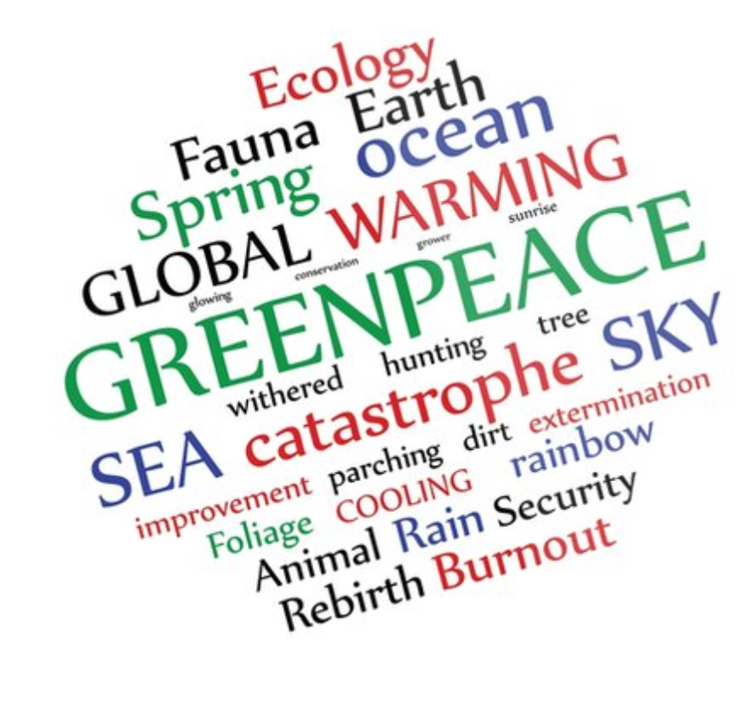

The size of words reflects how many times that word was used in responses. A photo of the compiled words will be available Oct. 1st.

