5/7/21 Eco-action

Delving Deeper

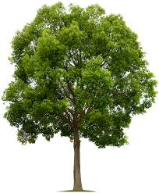

Invite a few family/friends to join you to prepare a ritual to honor trees. Invite others to share together later. Follow this pattern or create your own:

- Gather near a tree or trees. Leader sets the tone with a few words of welcome and explanation.

- Reading from Sacred Scripture: (your choice)

- Reading of an appropriate poem: (your choice)

- Invite people to share what trees mean to them.

- Sing (or dance?) an appropriate song: (your choice)

- Closing: Bless the tree(s) and one another.

- Socialize with appropriate refreshments. Use no plastic.

