A 2019 report from the International Renewable Energy Agency states: “Renewable energy is increasingly the cheapest source of new electricity...." Hope you found that true when you transitioned — or will!

11/6: 1. Take at least 5 minutes to ponder how the divine Mystery has lived and worked within creation for over 13.7 billion years! Be grateful for the sacred “love-force” active in Earth’s changing seasons and in us at this moment. Think about how our actions will affect “the cry of the poor, the cry of the earth” in our future story.

2. Read to a child (or to your inner one) the first 24 pages of Jennifer Morgan’s Born with a Bang (www.goodreads.com/book/show/380443.Born_with_a_Bang). Why do you think she speaks in the first person?

Delving deeper:

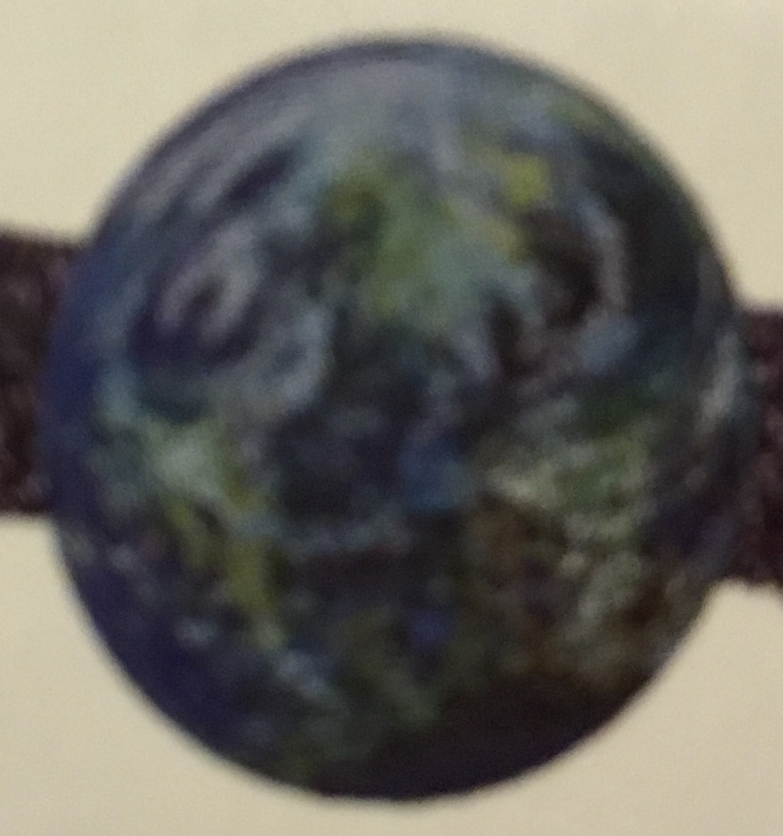
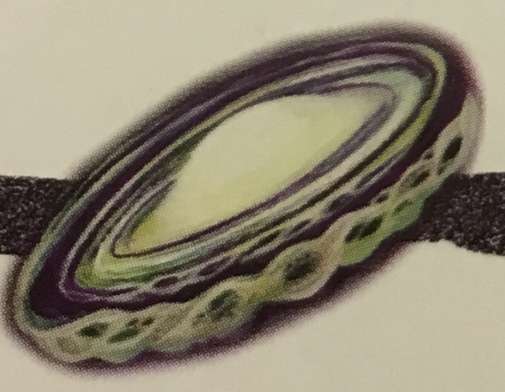
The time line below marks the first 9 billion of the over-13.7 billion years the love-force has been active in creation.

1. Place the Milky Way icon where you think it belongs.
2. Place the Earth icon where you think it belongs.
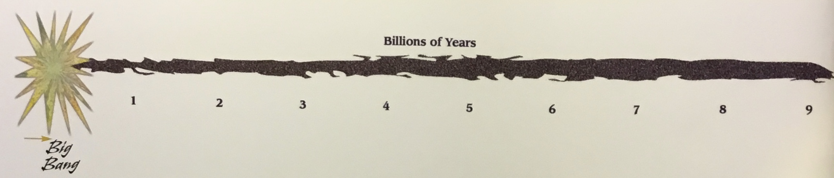
3. Check your answer on p. 40.
(Permission and best wishes given by author.)

4. Page 40 lists 12 things that our Universe learned in its first 8 1/2 billion years. Which one(s) do you consider most important for the SHCJ as we co-create Earth’s future?
5. If you wish, send your answer to #4 to terrishcj@aol.com by November 13. Answers (not names) will be shared in Newsnotes.

