ECO-ACTION FOR OCTOBER 16, 2020 – DELVING DEEPER:
Keeping in mind the divine presence empowering your actions, and strictly for your own use, decide how you feel about answering these weekly invitations:
* this doesn't interest me; * I'm willing to give this a try; * I'm eager to begin this; * I’m grateful we’re doing this.

Wherever you are is the right starting point.

- Choose your current level of commitment to caring for our common home by choosing one of the boxes below. Click on the Earth emoji and move it to the picture of your choice.
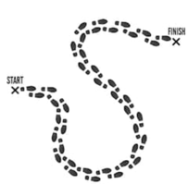

THIS IS NOT I AM READY I AM IN AND ON I AM DEEPLY
MY THING! TO GET GOING! THE GO! COMMITTED!

- Click on and move the image of the Earth to the word that best describes your relationship with the rest of creation.

What relationship? Domination Stewardship Intercommunion

You’ll receive these choices again next October.

